32.Design TM using simulator to perform string comparison where w={aba aba}

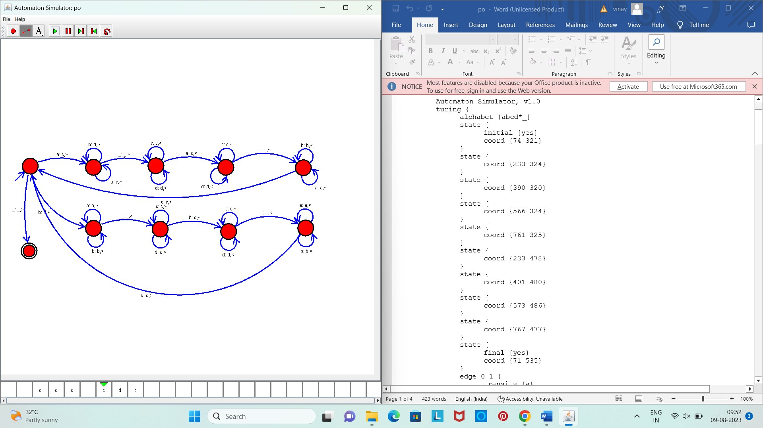

Result :

The given string comparision is performed well by the simulator by the above turing machine diagram